**Wheat Head Detection**

**Devendra Kumar Sahu**

TCR-Innovation Internship Final Project 1 (Wheat Head Detection)

**Source Code :-**

import os,ast

import pandas as pd

import numpy as np

from matplotlib import pyplot as plt

import matplotlib.patches as patches

import seaborn as sns

!ls global-wheat-detection

BASE_DIR="global-wheat-detection"

%%time

train_df = pd.read_csv(os.path.join(BASE_DIR, 'train.csv'))

sample_sub_df = pd.read_csv(os.path.join(BASE_DIR, 'sample_submission.csv'))

train_df.head()

sample_sub_df.head()

print(f'Shape of training data: {train_df.shape}')

print(f'Shape of given test data: {sample_sub_df.shape}')

print(f'# of unique images: {train_df["image_id"].nunique()}')

print(f'Unique heights and widths: {train_df["width"].unique()}, {train_df["height"].unique()}')

print(f'Minimum number of wheat heads: {max(train_df["image_id"].value_counts())}')

print(f'Minimum number of wheat heads: {len(train_df)/train_df["image_id"].nunique()}')

print(f'Total number of images: {len(os.listdir(os.path.join(BASE_DIR, "train")))}')

sns.distplot(train_df['image_id'].value_counts(), kde=False)

plt.xlabel('# of wheat heads')

plt.ylabel('# of images')

plt.title('# of wheat heads vs. # of images')

plt.show()

train_df[['x_min','y_min', 'width', 'height']] = pd.DataFrame([ast.literal_eval(x) for x in train_df.bbox.tolist()], index= train_df.index)

train_df = train_df[['image_id', 'bbox', 'source', 'x_min', 'y_min', 'width', 'height']]

train_df

sns.distplot(train_df['width'] * train_df['height'], kde=False)

plt.xlabel('Area of bbox')

plt.ylabel('# of images')

plt.title('Area of bbox vs. # of images')

plt.show()

fig, ax = plt.subplots(nrows=2, ncols=4, figsize=(20, 10))

count=0

for row in ax:

for col in row:

img = plt.imread(f'{os.path.join(BASE_DIR, "train", train_df["image_id"].unique()[count])}.jpg')

col.grid(False)

col.set_xticks([])

col.set_yticks([])

col.imshow(img)

count += 1

plt.show()

fig, ax = plt.subplots(nrows=2, ncols=4, figsize=(20, 10))

count=0

for row in ax:

for col in row:

img = plt.imread(f'{os.path.join(BASE_DIR, "train", train_df["image_id"].unique()[-count])}.jpg')

col.grid(False)

col.set_xticks([])

col.set_yticks([])

col.imshow(img)

count += 1

plt.show()

def get_bbox(image_id, df, col, color='white'):

bboxes = df[df['image_id'] == image_id]

for i in range(len(bboxes)):

rect = patches.Rectangle(

(bboxes['x_min'].iloc[i], bboxes['y_min'].iloc[i]),

bboxes['width'].iloc[i],

bboxes['height'].iloc[i],

linewidth=2,

edgecolor=color,

facecolor='none')

col.add_patch(rect)

fig, ax = plt.subplots(nrows=2, ncols=2, figsize=(20, 20))

count=0

for row in ax:

for col in row:

img_id = train_df["image_id"].unique()[count]

img = plt.imread(f'{os.path.join(BASE_DIR, "train", img_id)}.jpg')

col.grid(False)

col.set_xticks([])

col.set_yticks([])

get_bbox(img_id, train_df, col, color='red')

col.imshow(img)

count += 1

plt.show()

fig, ax = plt.subplots(nrows=2, ncols=2, figsize=(20, 20))

count=0

for row in ax:

for col in row:

img_id = train_df["image_id"].unique()[-count]

img = plt.imread(f'{os.path.join(BASE_DIR, "train", img_id)}.jpg')

col.grid(False)

col.set_xticks([])

col.set_yticks([])

get_bbox(img_id, train_df, col,color='red')

col.imshow(img)

count += 1

plt.show()

image_id = (train_df['image_id'].value_counts() == 116).index[0]

img = plt.imread(f'{os.path.join(BASE_DIR, "train", image_id)}.jpg')

fig, ax = plt.subplots(1, figsize=(12, 12))

ax.grid(False)

ax.set_xticks([])

ax.set_yticks([])

ax.axis('off')

get_bbox(image_id, train_df, ax, color='red')

ax.imshow(img)

plt.plot()

all_images = os.listdir(os.path.join(BASE_DIR, 'train'))

all_images = set([x[:-4] for x in all_images])

images_with_bbox = set(list(train_df['image_id']))

images_without_bbox = list(all_images - images_with_bbox)

print(f'Total number of images without wheat heads: {len(images_without_bbox)}')

fig, ax = plt.subplots(nrows=2, ncols=4, figsize=(20, 10))

count=20

for row in ax:

for col in row:

img_id = images_without_bbox[count]

img = plt.imread(f'{os.path.join(BASE_DIR, "train", img_id)}.jpg')

col.grid(False)

col.set_xticks([])

col.set_yticks([])

col.imshow(img)

count += 1

plt.show()

**Output:-**

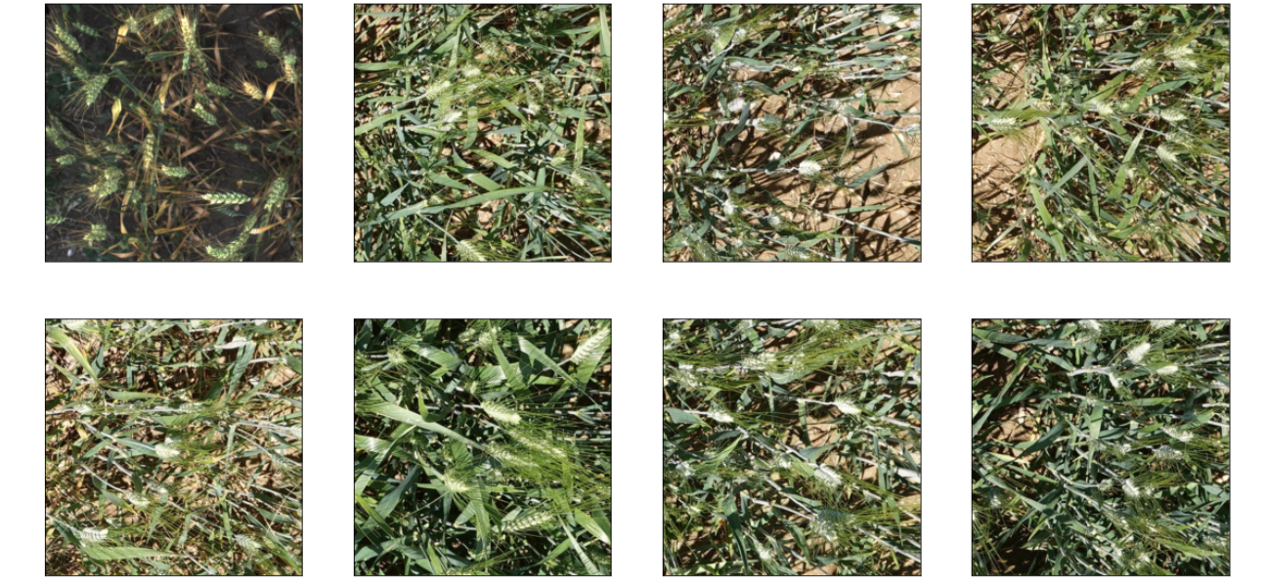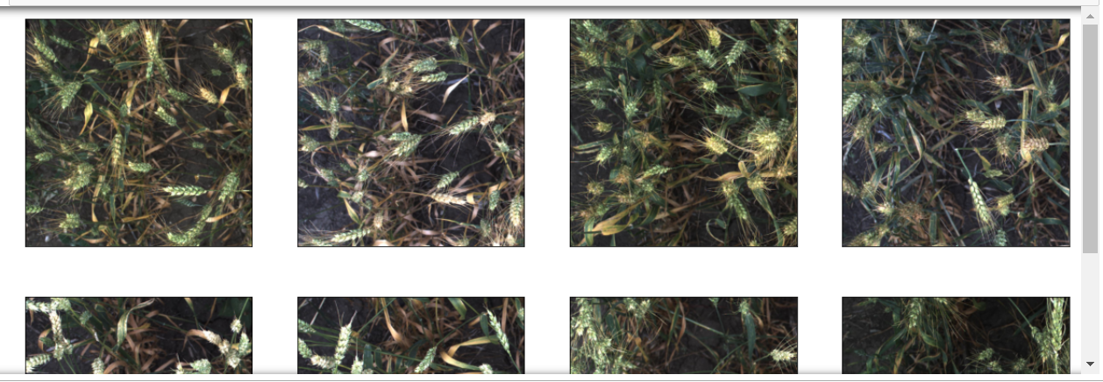**Wheat Images**

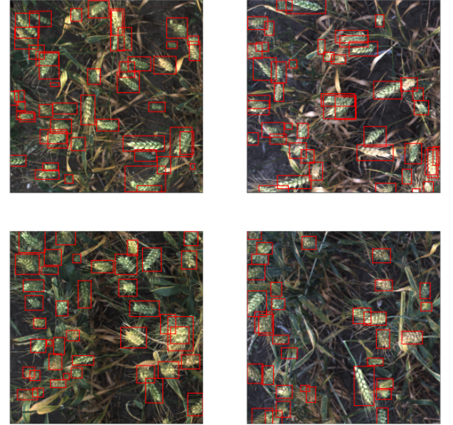**Wheat Detected Images**

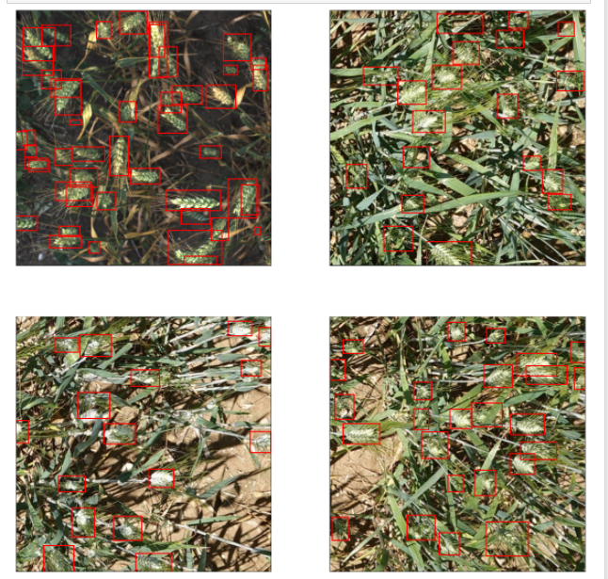

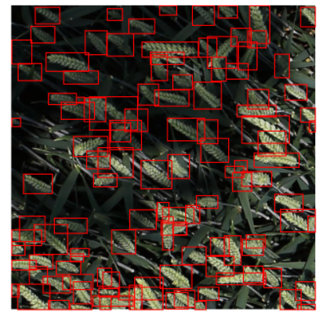

**No wheat Detected**

